Discussion of Results – Inter-model Comparison

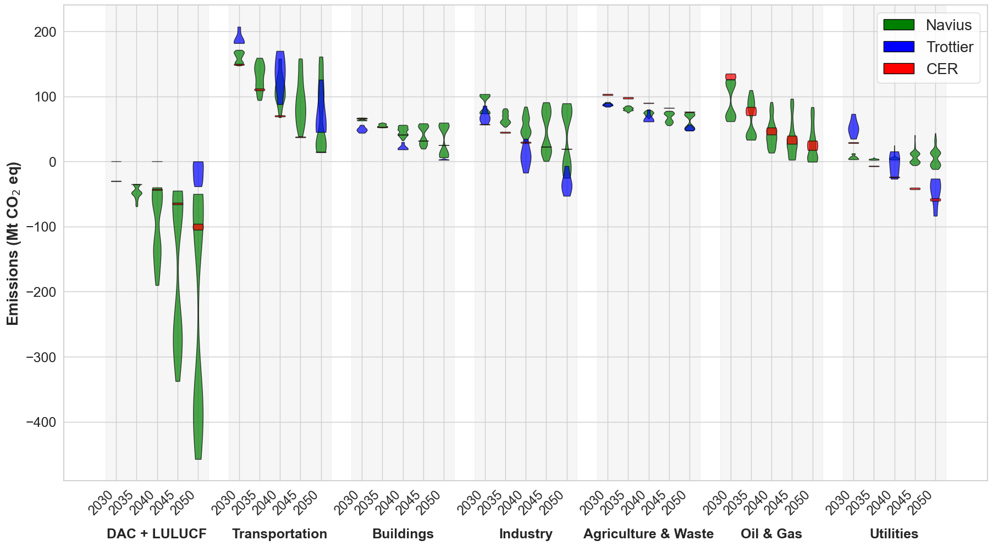
Carbon removal volumes and methods vary significantly between models. Figure 5 presents a violin plot of emissions and CDR sequestration levels by sector and year for all net-zero scenarios across the Navius, Trottier, and CER databases. The chosen CDR vehicles differ from one model to the next: Navius primarily depends on DAC and LULUCF, Trottier favors DAC and BECCS, and CER opts for a mixture of all three. Furthermore, BECCS, whose presence can be seen through negative emissions in the industry and utilities sectors, can take the form of either biomass-based electricity or hydrogen production (paired with CCS). However, it is important to note that negative emissions in industry and utilities reflect the net impact of a combination of factors, including continuing fossil-based activities, point-source CCS, supply- and demand-side emission reductions, and net-negative operations involving biogenic carbon – these effects are shaped by how each model categorizes sectoral emissions and allocates carbon flows, particularly in distinguishing between emission reduction and carbon removal pathways. While all the databases do indicate that DAC deployment levels will increase with time, the magnitudes from year to year and the rates of increase are different. In 2050, the CER and Trottier models exhibit similar levels of carbon removal in their most CDR-intensive scenarios, each reaching approximately 160–165 Mt of net sequestration. In contrast, the Navius model reaches up to 457 Mt sequestered, primarily through DAC, driven by its broader scenario space and inclusion of extreme techno-economic assumptions – such as high costs for each of solar, wind, batteries, CCS, and hydrogen, high market price of oil, and low land offset availability. These conditions compel greater reliance on engineered CDR, especially DAC. However, Navius also includes numerous scenarios that achieve net zero with no DAC (via combinations of deep decarbonization, BECCS, and land-use offsets), underscoring its thorough treatment of uncertainty rather than a systematic preference for high-CDR pathways. The sectors also generally display a trend of declining emissions with time, with transportation and industry showing more emission variability than other sectors.
Emissions and Sequestration by Year, Sector, and Model. This violin plot presents both CDR (DAC + LULUCF) sequestration capacities and emissions in Canada for shared sectoral categories from 2030 to 2050 in five-year intervals across the Trottier, CER, and Navius datasets. BECCS removals are accounted for as part of the negative emissions exhibited by industry and utilities in some scenarios.

